LAB EXPERIMENTS
TOPIC 3
NAME: CH. NAGA ANJALI
REG NO: 192372201
COURSE CODE: CSA0608
COURSE NAME: DESIGN AND ANALYSIS OF ALGORITHM

- Sequential Search

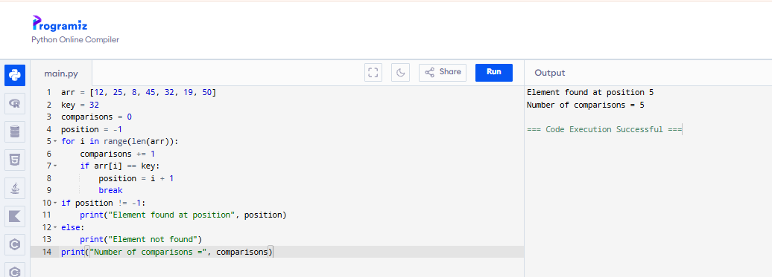
- Implement Sequential Search for an unsuccessful search.
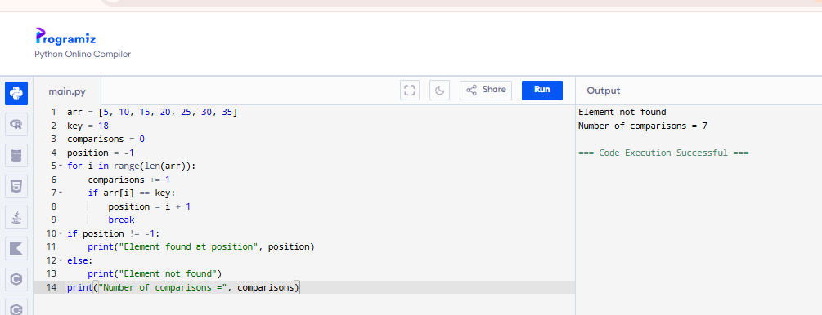

3.Write a program to find the first occurrence of an element using Sequential Search.
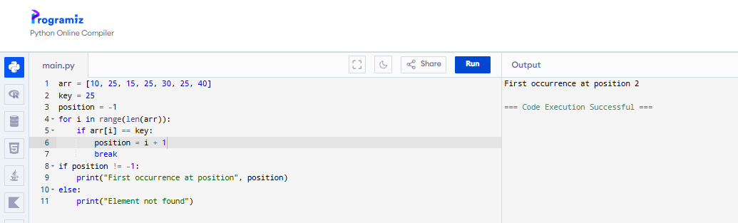
4.Implement Sequential Search to find all occurrences of a given element.
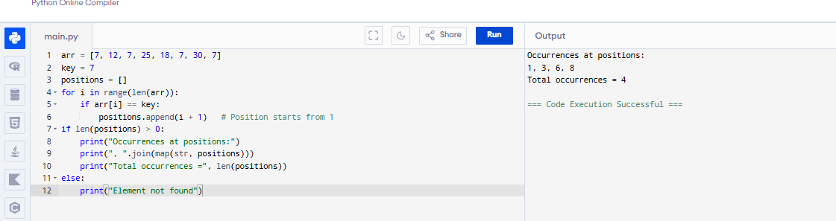
5. Write a program to count: Total comparisons, Total matches, Total mismatches
during Sequential Search.
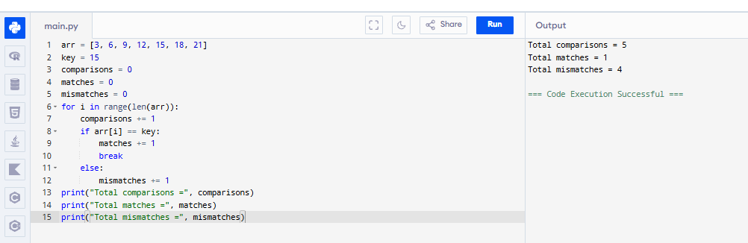

6.Implement Sentinel Sequential Search and compare it with ordinary Sequential Search.
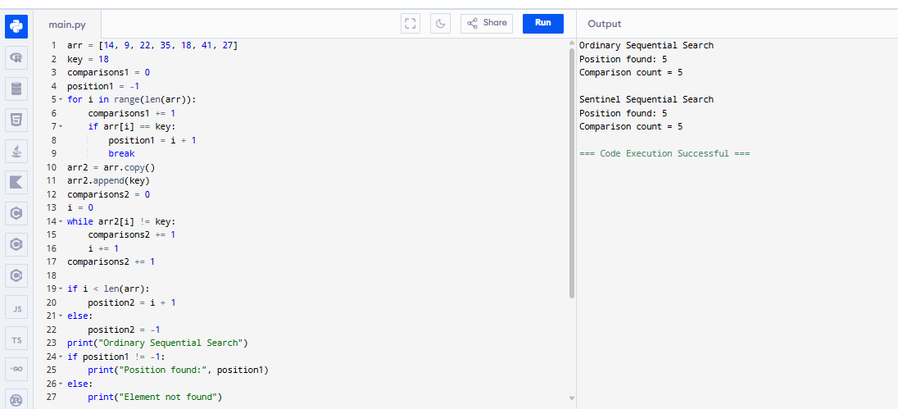
7. Write a program to perform Sequential Search on an array of student register numbers.
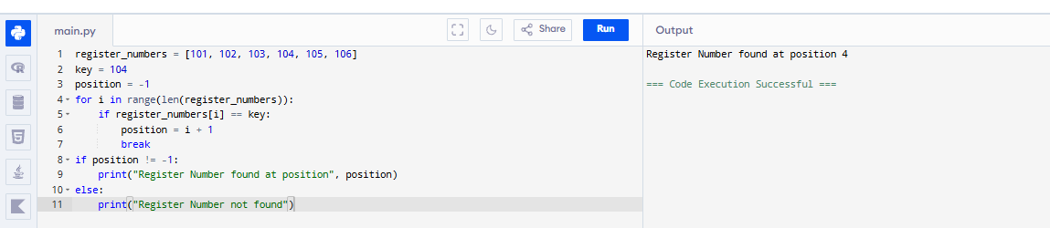
8. Implement Sequential Search for string data.
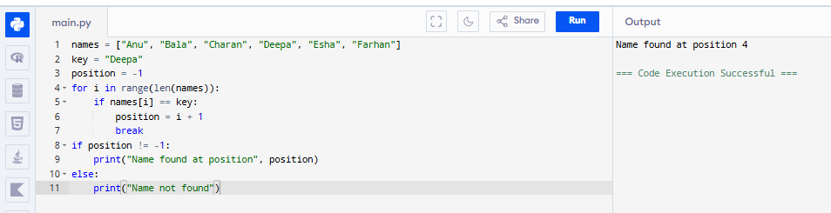

9. Write a program to perform Sequential Search on a 2-D matrix.
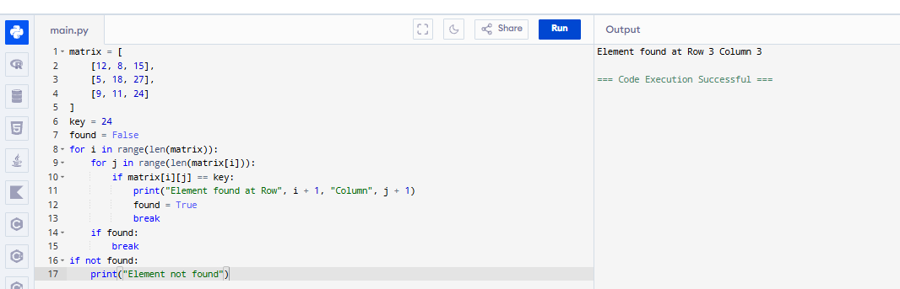
10. Implement Sequential Search and analyze its performance.
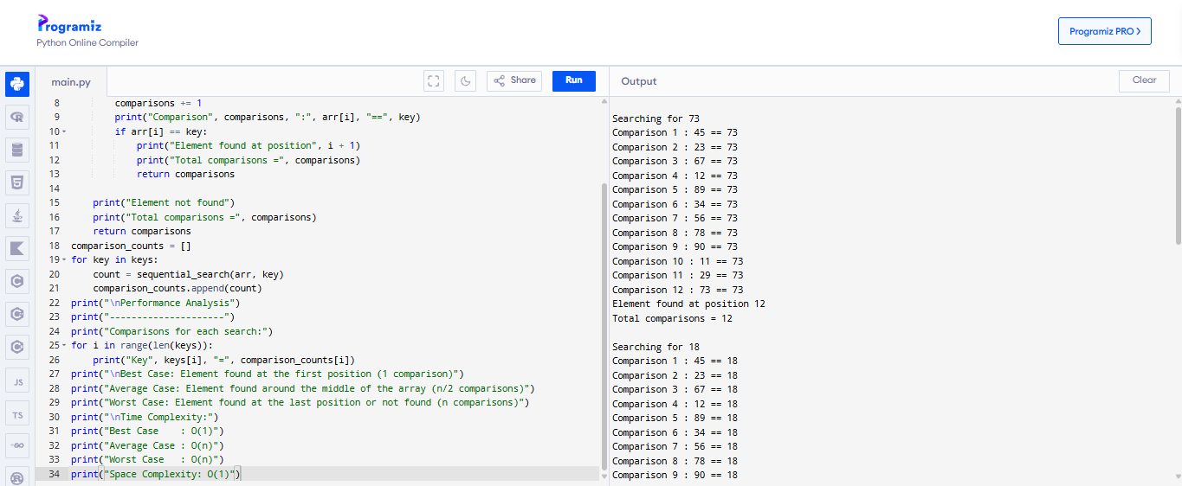

Brute Force String Matching
1.Implement the Brute Force String Matching Algorithm to search for a pattern in a given text.
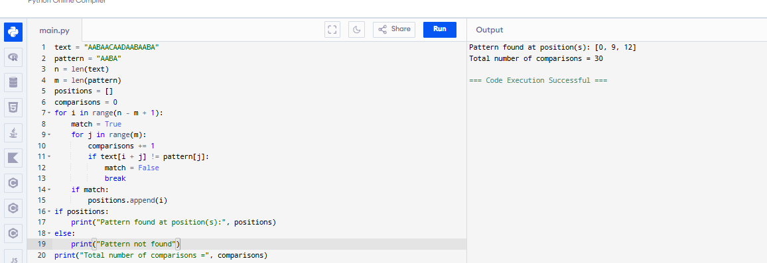
2.Write a program to find all occurrences of a pattern in a text using Brute Force String Matching.
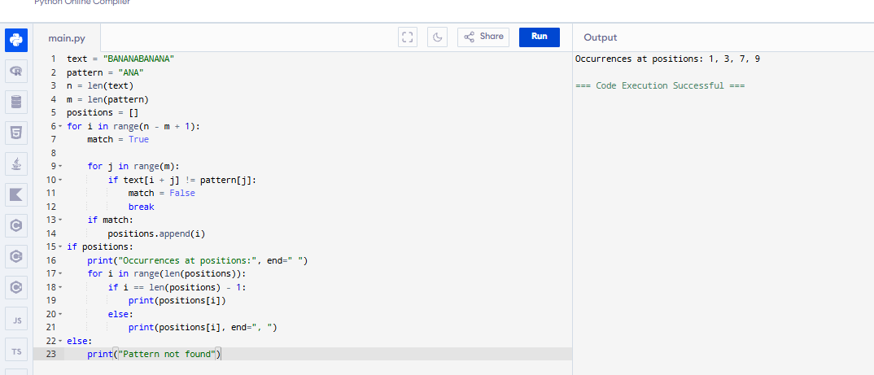3. Implement Brute Force String Matching and display the comparison table for each alignment.
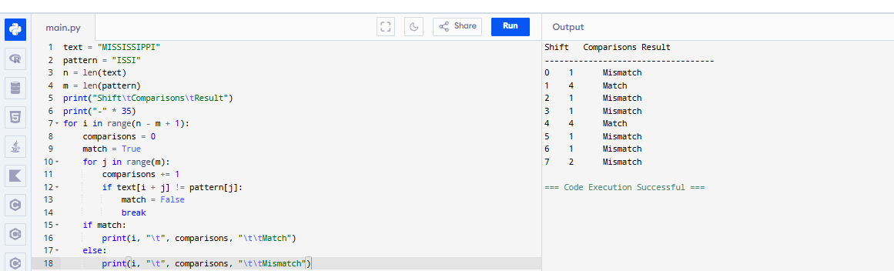
4.Write a program to count, Total character comparisons, Total matches, Total mismatches during Brute Force String Matching.
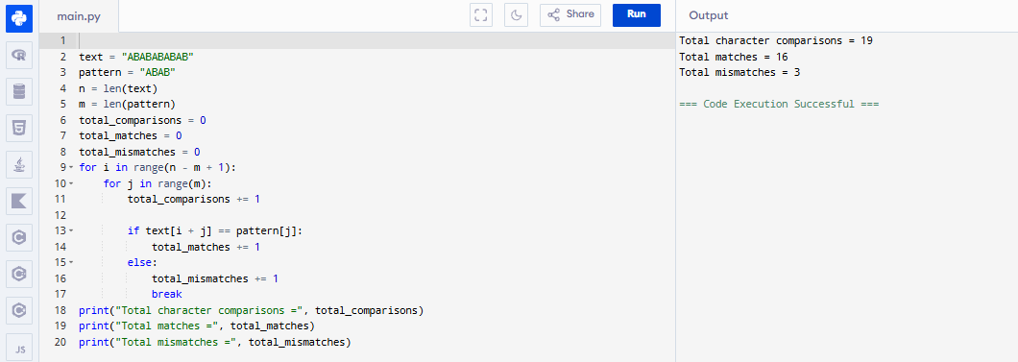
5. Implement Brute Force String Matching and determine whether the search is:
● Best Case
● Average Case
● Worst Case
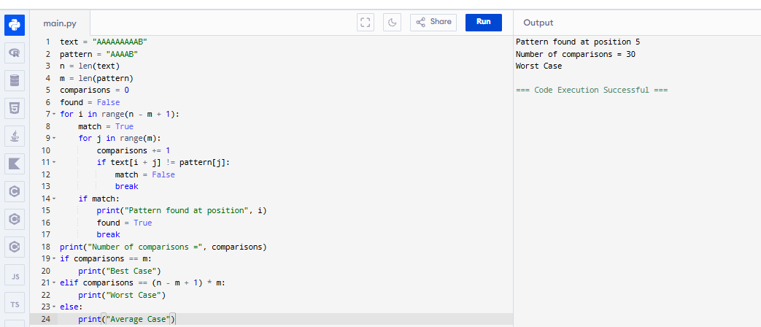
6. Write a program that searches for a pattern in a text and reports the first occurrence only using Brute Force String Matching.
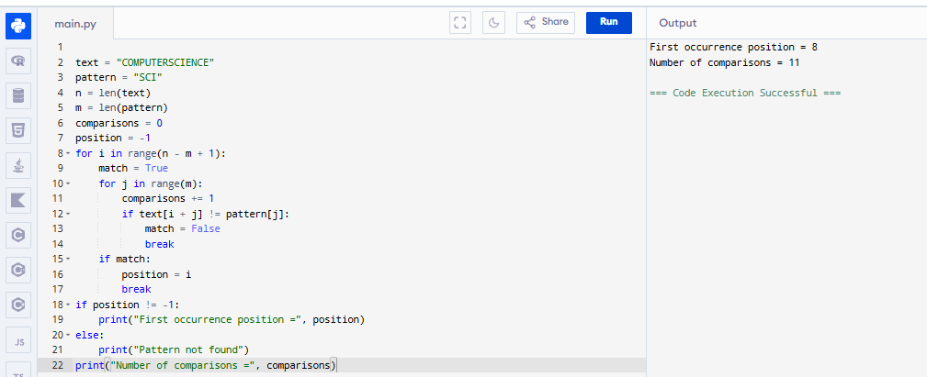
7. Implement Brute Force String Matching for case-insensitive searching.
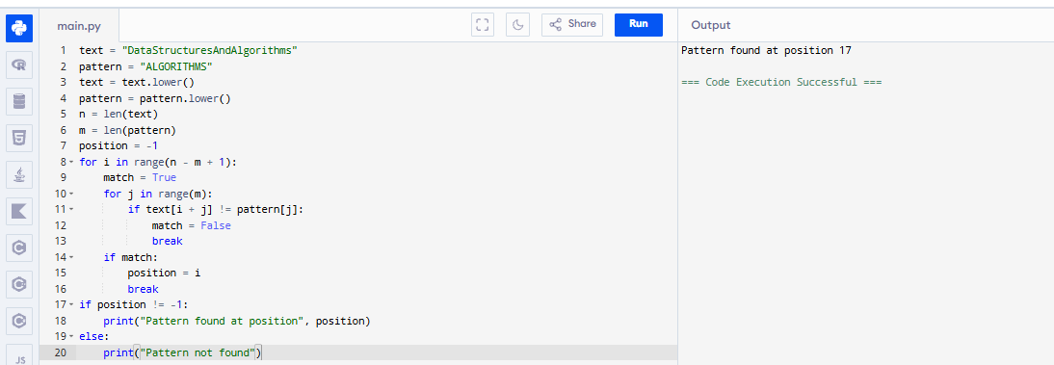
8. Write a program to compare the execution of Brute Force String Matching for: 1. Successful search 2. Unsuccessful search.
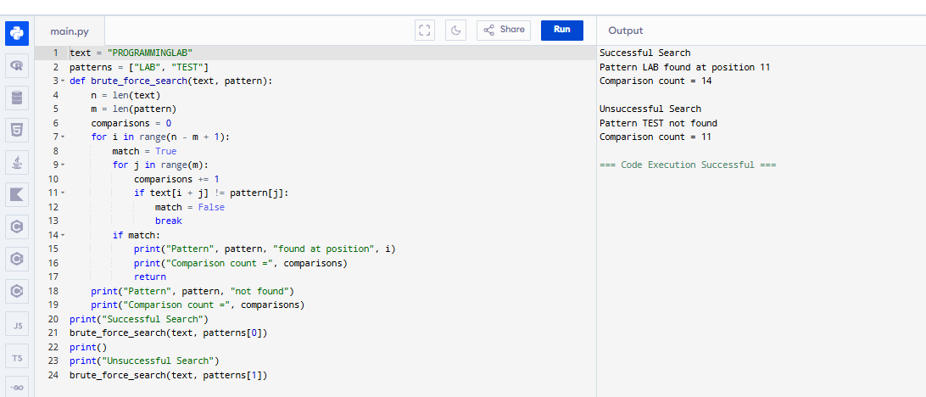
9. Implement Brute Force String Matching and display every alignment of the pattern with the text.
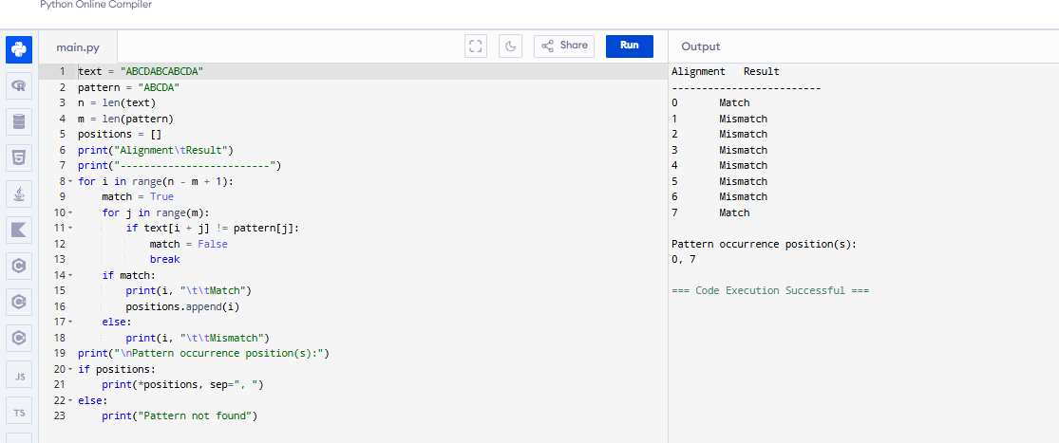
10. Write a complete program for Brute Force String Matching and perform complexity analysis.
